Insert School Logo

Semester Two Examination 2018

Question/Answer Booklet

MATHEMATICS
METHODS UNITS 3 & 4

Section One:
Calculator–free

Student Name: _____________________________________
Teacher‘s Name: _____________________________________

Time allowed for this section
Reading time before commencing work: five minutes
Working time for paper: fifty minutes

Material required/recommended for this section

To be provided by the supervisor
This Question/Answer booklet
Formula Sheet

To be provided by the candidate
Standard items: pens(blue/black preferred), pencils(including coloured), sharpener, correction tape/fluid, erasers, ruler, highlighters

Special Items: nil

Important note to candidates
No other items may be taken into the examination room. It is your responsibility to ensure that you do not have any unauthorised notes or other items of a non–personal nature in the examination room. If you have any unauthorised material with you, hand it to the supervisor before reading any further.

Structure of this paper

 | Number of questions available | Number of questions to be attempted | Working time (minutes) | Marks available | Percentage of exam
Section One  Calculator—free | 9 | 9 | 50 | 50 | 35
Section Two  Calculator—assumed | 11 | 11 | 100 | 100 | 65
 |  |  |  |  | 100

Instructions to candidates

- The rules for the conduct of Western Australian external examinations are detailed in the Year 12 Information Handbook 2018. Sitting this examination implies that you agree to abide by these rules.

- Answer the questions according to the following instructions.

Section One: Write answers in this Question/Answer Booklet. Answer all questions.

Show all your working clearly. Your working should be in sufficient detail to allow your
answers to be checked readily and for marks to be awarded for reasoning. Incorrect
answers given without supporting reasoning cannot be allocated any marks. For any
question or part question worth more than two marks, valid working or justification is
required to receive full marks. If you repeat an answer to any question, ensure that you
cancel the answer you do not wish to have marked.

It is recommended that you do not use pencil, except in diagrams.

- You must be careful to confine your responses to the specific questions asked and to follow any instructions that are specific to a particular question.

- Spare pages are included at the end of this booklet. They can be used for planning your responses and/or as additional space if required to continue an answer.
- Planning: If you use the spare pages for planning, indicate this clearly at the top of the
page.
- Continuing an answer: If you need to use the space to continue an answer, indicate in the original answer space where the answer is continued, i.e. give the page number. Fill in the number of the question that you are continuing to answer at the top of the page.

- The Formula Sheet is not handed in with your Question/Answer Booklet.

Section One: Calculator–free 50 marks

This section has nine (9) questions. Attempt all questions. Write your answers in the spaces provided.

Spare pages are included at the end of this booklet. They can be used for planning your responses and/or as additional space if required to continue an answer.

- Planning: If you use the spare pages for planning, indicate this clearly at the top of the page.
- Continuing an answer: If you need to use the space to continue an answer, indicate in the original answer space where the answer is continued, i.e. give the page number. Fill in the number of the question(s) that you are continuing to answer at the top of the page.

Working time: 50 minutes

Question 1 (7 marks)

Let 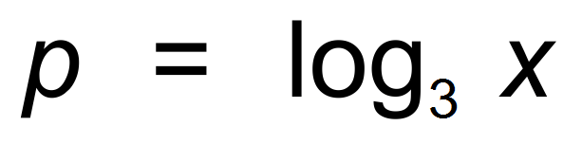.

(a) State the value 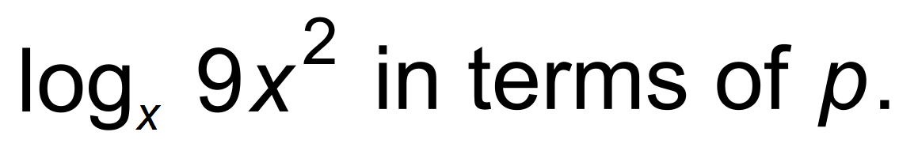 (3 marks)

(b) Evaluate 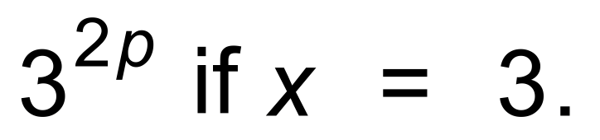 (2 marks)

(c) Evaluate 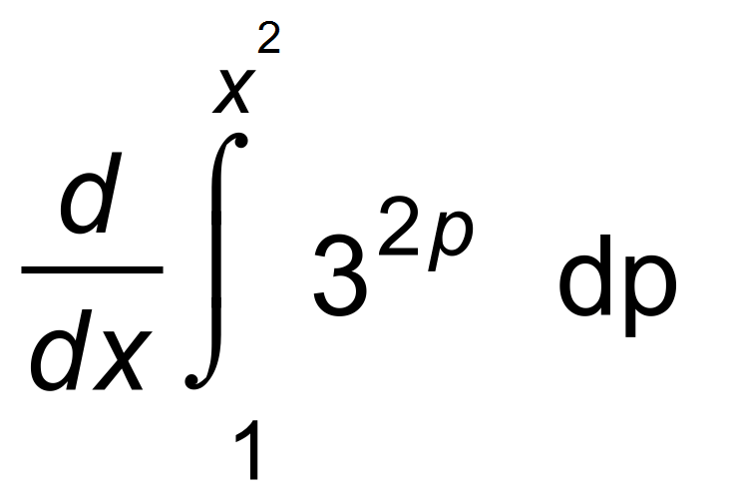 (2 marks)

Question 2 (8 marks)

Petra inflates her beach ball. Over the first six seconds, the volume of the ball is
given by 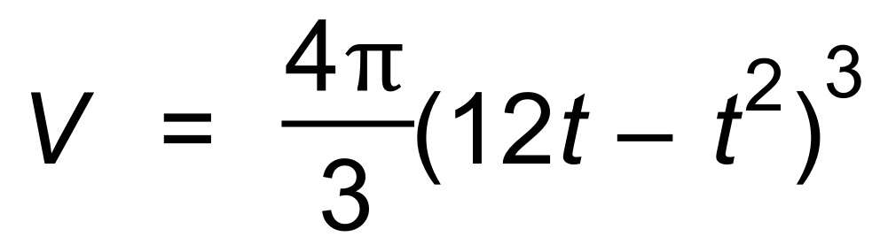.

(a) Use Calculus to determine when the maximum volume is achieved. (4 marks)

(b) (i) Determine the relationship between the radius of the ball ( r ) and t. (2 marks)

(ii) Show that this verifies your answer from (a). (2 marks)

Question 3 (6 marks)

Consider the graph of f (x), and the table of values of f (x) for certain x values.
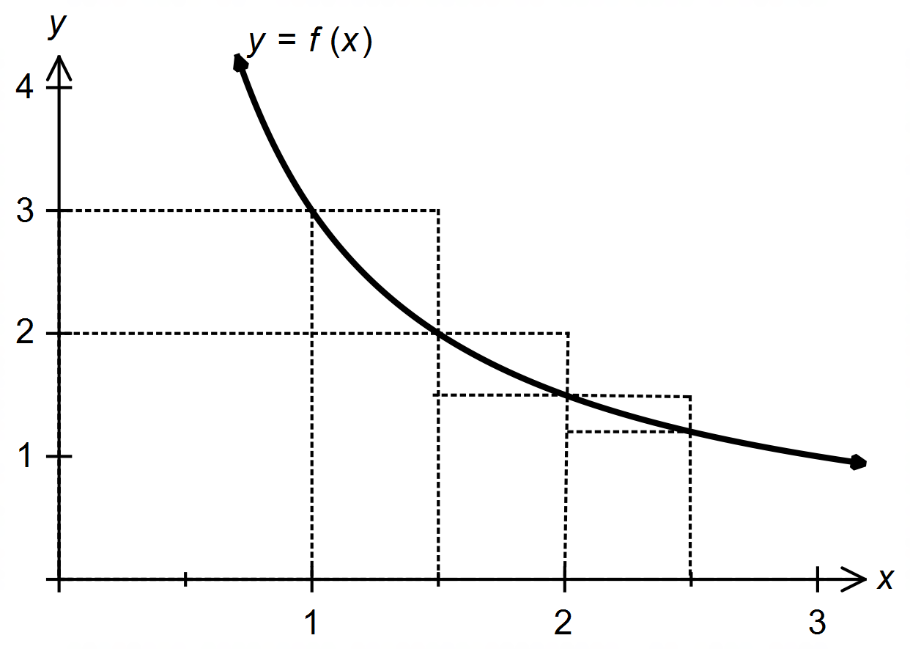

x | 1 | 1.5 | 2 | 2.5
f (x) | 3 | 2 | 1.5 | 1.2

(a) By considering the rectangles drawn on the graph, calculate the value of p and q, where:
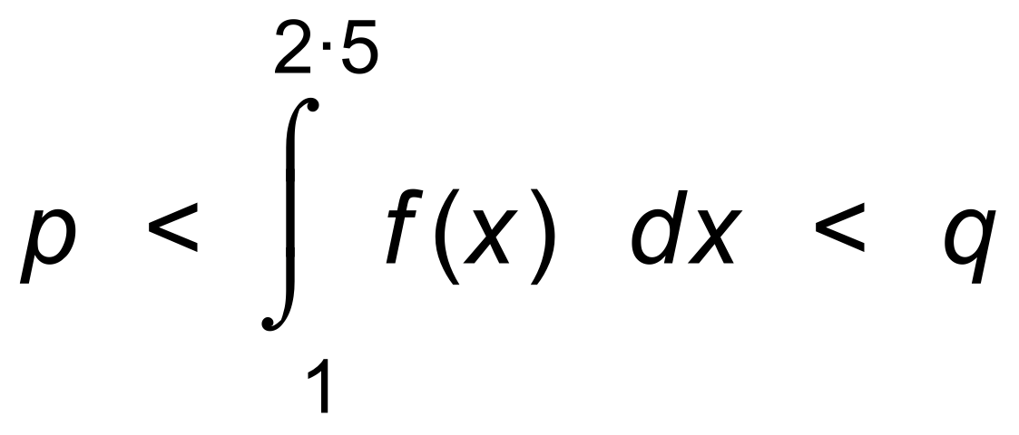 (4 marks)

(b) Given that 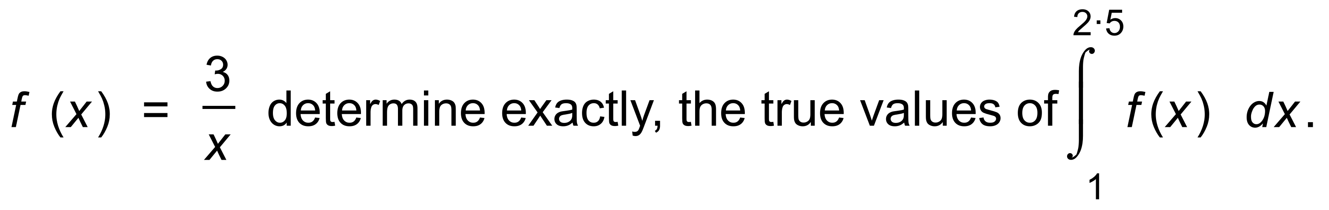 (2 marks)
Question 4 (5 marks)

Albert discovered an old die, which wobbled when he rolled it.
He rolled it many times and recorded the results.
The relative frequencies are shown in the histogram as shown.

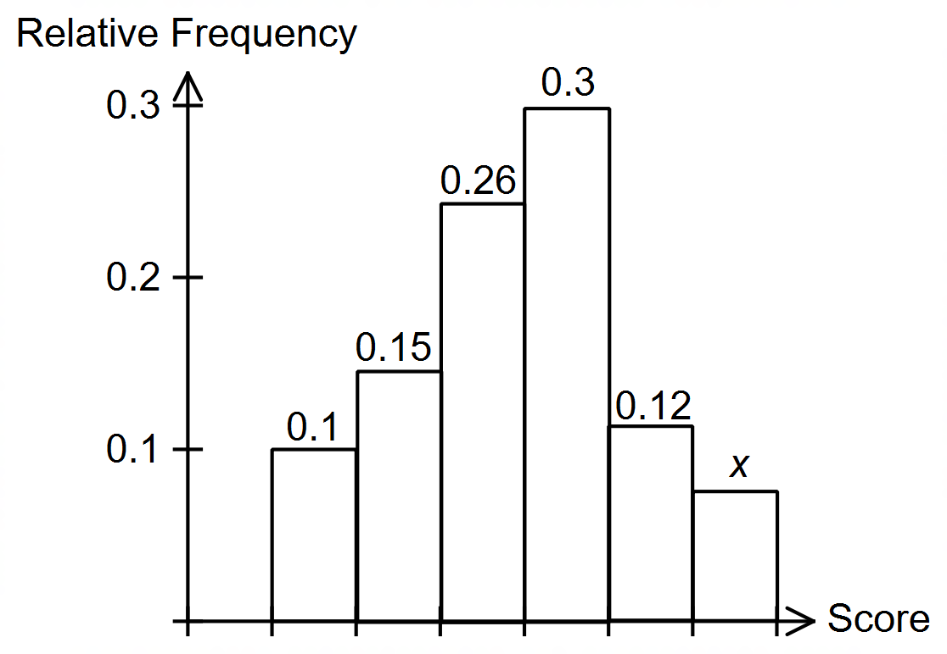

(a) What is the value of x? (1 mark)

(b) What is the probability that the next roll would result in a 1 or a 2? (1 mark)

(c) What is the probability that the next two rolls would both result in a 1 or
both in a result of a 2? (2 marks)

(d) How does this histogram compare with a histogram for an unbiased die? (1 mark)

Question 5 (6 marks)

(a) Differentiate 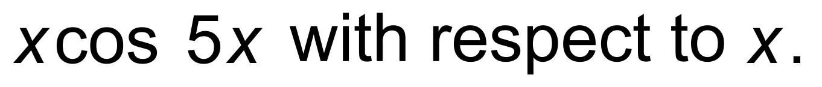 (2 marks)

Hence,

(b) show that 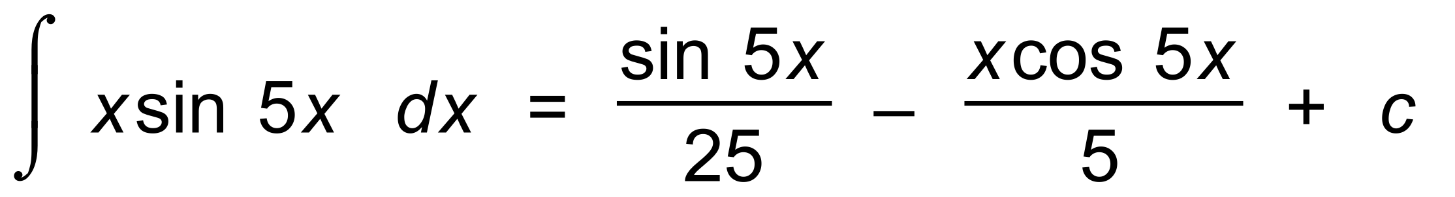 (4 marks)

Question 6 (5 marks)

Solve (5 marks)

Question 7 (5 marks)

(a) Sketch the curves 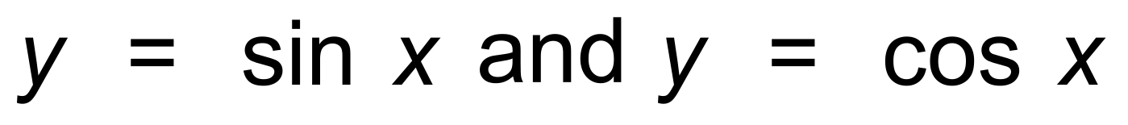 on the axes below, for the
domain given. (2 marks)

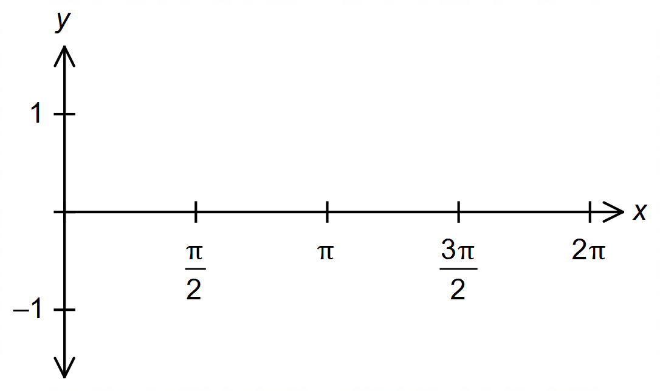

Hence, or otherwise,

(b) determine the area enclosed between the curves between x = 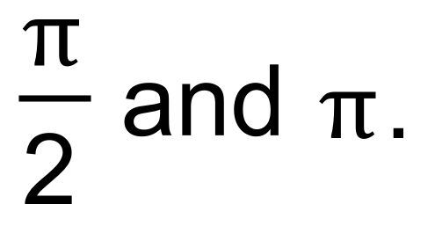 (3 marks)

Question 8 (3 marks)

Two independent samples of different sizes were taken from a population.
The first sample had sample size n₁, and the second sample had sample size n₂,
where 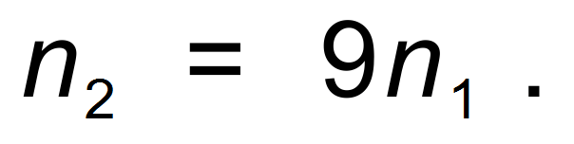
The sample proportions of adults in the samples were the same.
Confidence intervals were calculated for both samples at the 90% level.
Determine the ratio of the two margins of error. That is 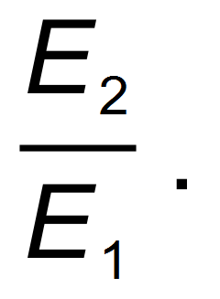 (3 marks)

Question 9 (5 marks)

(a) Determine 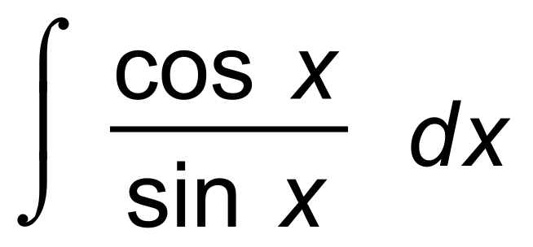 . (2 marks)

Hence, or otherwise,

(b) evaluate 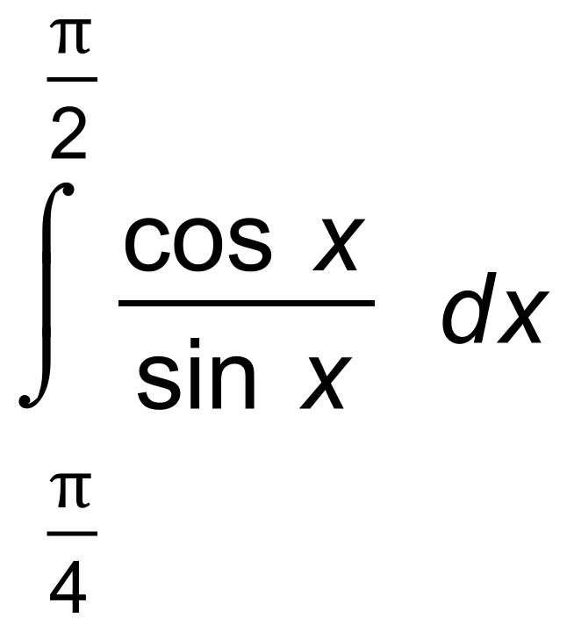 exactly. (3 marks)

End of Section One
Additional working space

Question number(s): ……………………

